DMI C++ FRONT-END TOOL

Model Selection (First Screen)
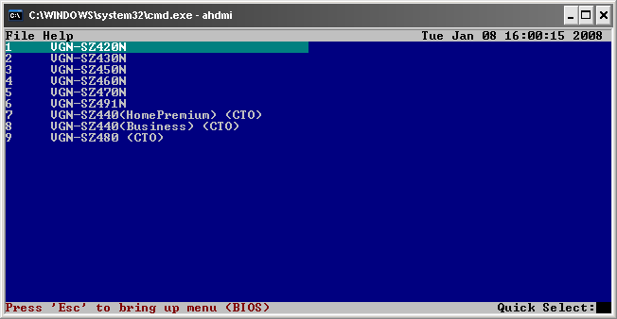
Use the up/down keys to select a model; or type in a line number.

Press enter to set the DMI information for that model.

Tool Menus
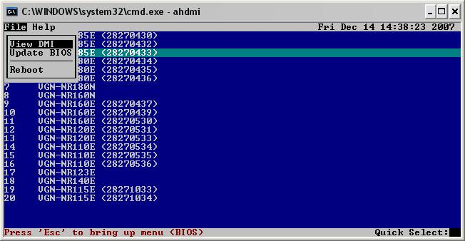
To bring up the menu at the top, press Esc.

Alt-F – File menu
Alt-H – Help menu

About Menu
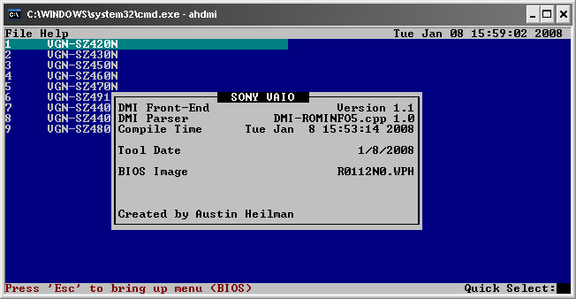
AHDMI Version

Module date

Tool BIOS version

DMI Write
To move to previous field, use up arrow.
To move to next field use down arrow, tab or enter.
When data is entered into a field, it will first erase the current data and write the new.
If backspace is pressed on a highlighted field, it will only remove the last character.
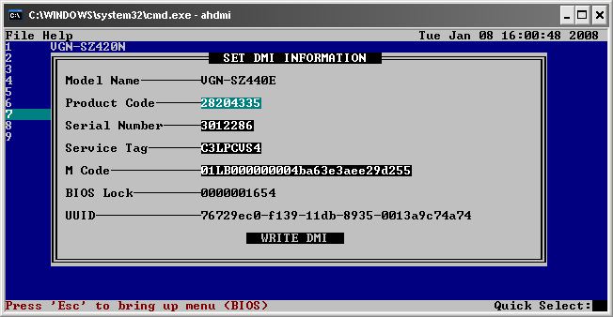
Static (not editable data)
Selected field is highlighted in cyan.
Press enter to set.
Will turn green if valid, red if not.
Unedited fields have a black background.

